**Project Design Phase-I**

**Solution Architecture**

|  |  |
| --- | --- |
| Date | 14 October 2022 |
| Team ID | PNT2022TMID11377 |
| Project Name | Project-Smart Farmer-IOT Enabled Smart Farming Application |
| Maximum Marks | 4 Marks |

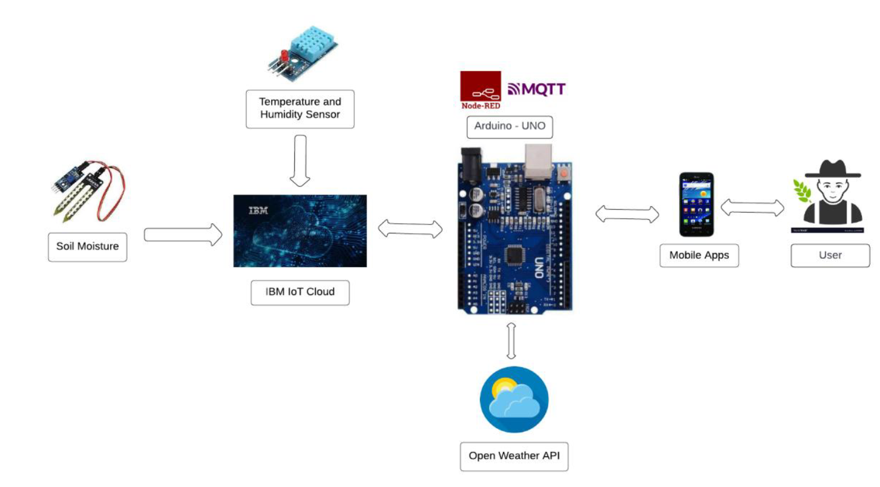

* The different soil parameters temperature, soil moistures and then humidity are sensed using different sensors and obtained value is stored in the ibm cloud.
* Arduino UNO is used as a processing Unit that process the data obtained from the sensors and whether data from the weather API.
* NODE-RED is used as a programming tool to write the hardware, software and APIs. The MQTT protocol is followed for the communication.
* All the collected data are provided to the user through a mobile application that was developed using the MIT app inventor. The user could make a decision through an app, weather to water the crop or not depending upon the sensor values. By using the app they can remotely operate to the motor switch.